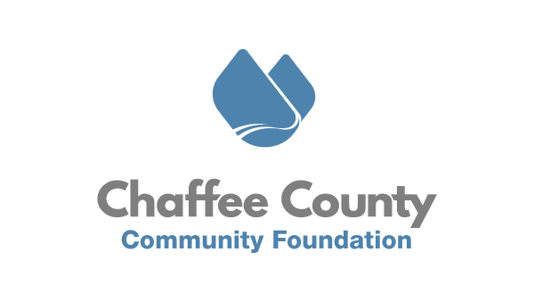
May 13, 2020
FOR IMMEDIATE RELEASE
CCCF Launches Sangre de Cristo Electric’s Community Grants Application

Chaffee County, CO – The Chaffee County Community Foundation (CCCF) is announcing the opening of the application process for organizations interested in applying to Sangre de Cristo Electric Association’s (SDCEA) Community Grants program. The program has a total budget of $32,350 to be awarded to organizations serving residents living in Chaffee, Custer, Lake, and Fremont counties.

The SDCEA board has entered into a partnership with CCCF to bring more consistency, transparency, and impartiality to their community grants process. For 2020, CCCF has built an online application through which organizations can quickly and consistently request SDCEA support. CCCF will form a community grants review committee to review, rank, and conduct site visits with applicants before making final funding decisions.

The online application is “live” as of Tuesday, May 12th, 2020 and has a deadline of Friday, June 5th, 2020 at 5pm. Applications will be reviewed and site visits conducted in June, with funding being decided and awarded in July, 2020. Eligible organizations can request up to $5,000 in general operating, capital, or programmatic funds. Applicants must demonstrate clear connection to SDCEA’s 2020 community grant program priorities of community health, basic needs, disaster preparedness or relief including search and rescue, and animal welfare.

For more detailed eligibility and program criteria, or to apply, visit CCCF’s May 12th blog post: https://www.chaffeecommunity.org/blog

Or you may use the direct portal link to apply: https://www.grantinterface.com/Home/Logon?urlkey=ccgrants

Organizations with questions or Chaffee, Custer, Lake, or Fremont county residents who are interested in applying for the grant review committee may email grants@chaffeecommunity.org.

Follow CCCF on Facebook and Instagram, or sign up for their newsletter at www.chaffeecommunity.org to get notifications and updates.
Simple idea. Lasting impact.

###
About Chaffee County Community Foundation (CCCF)
CCCF envisions a resilient Chaffee County where residents, nonprofits, businesses, and governments are thriving, interconnected, and well resourced. CCCF’s mission is to act as a catalyst to inspire positive change through the power of philanthropy to enrich the lives of all people in Chaffee County. To do this, CCCF is working with nonprofits, residents, businesses, and municipal governments to increase philanthropy, provide capacity building and technical support to nonprofits, and invest in catalytic projects in the areas of Community Vitality, Community Health, and Community Capacity. In addition, CCCF aims to act as a ‘center for the common good’ by holding space for community conversations
and dialogue on tough issues. Learn more at www.chaffeecommunity.org.

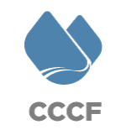
Joseph Teipel
Executive Director
(719) 204-5071
joseph@chaffeecommunity.org

