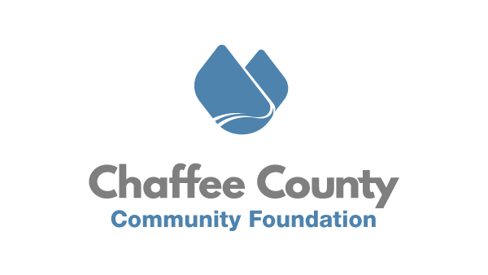

January 12th, 2020
FOR IMMEDIATE RELEASE
CCCF Opens Applications BV & Salida Community Grants
Chaffee County, CO – The Chaffee County Community Foundation (CCCF) announces the opening of the applications for nonprofit organizations seeking grant assistance from the Town of Buena Vista or the City of Salida, or both. Applications will be accepted from Tuesday, January 19th through Thursday, February 18th.

The Town of Buena Vista Trustees and the Salida City Council have entered into a partnership with CCCF to bring more consistency, transparency, and impartiality to their community grants processes. Beginning in 2020, CCCF designed and administered a separate online application process for each municipality to which organizations could quickly and consistently request grant support from each Buena Vista and Salida. In 2021, CCCF will combine the community grants application process to create a single application for both municipalities. This will not only lower the burden on nonprofit organizations, but also allow for one Review Committee to review, rank, and conduct site visits with each applicant organization. This committee will then submit their funding recommendations to each municipality for approval.

Any 501c3 organization in good standing serving either (or both!) Buena Vista or Salida residents is eligible to apply for funding. While there is no maximum award, grant awards average $2,800 for programs serving a single municipality. Any organization that received funding from either municipality in 2020 is required to submit a Colorado Common Grant Report either prior or with their 2021 application. Organizations who fail to do this will not be considered for funding. More information on the grant program, as well as the Common Grant Report can be accessed at CCCF’s website here: www.chaffeecommunity.org/communitygrants.

“Last year laid bare the crucial role our nonprofits play in our community. CCCF is thrilled to join both BV and Salida again to invest in their capacity, projects and programs. By building a more streamlined process, CCCF is working diligently to lower administrative burdens on nonprofits.” Says CCCF Executive Director Joseph Teipel.
###
About Chaffee County Community Foundation (CCCF)
CCCF envisions a resilient Chaffee County where residents, nonprofits, businesses, and governments are thriving, interconnected, and well resourced. CCCF’s mission is to act as a catalyst to inspire positive change through the power of philanthropy to enrich the lives of all people in Chaffee County. To do this, CCCF is working with nonprofits, residents, businesses, and municipal governments to increase philanthropy, provide capacity building and technical support to nonprofits, and invest in catalytic projects in the areas of Community Vitality, Community Health, and Community Capacity. In addition, CCCF aims to act as a ‘center for the common good’ by holding space for community conversations
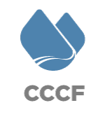
and dialogue on tough issues. Learn more at www.chaffeecommunity.org.
Joseph Teipel Executive Director (719) 204-5071
joseph@chaffeecommunity.org

