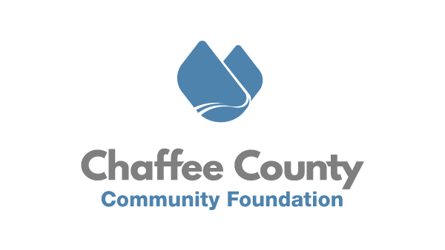

March 26th, 2021
FOR IMMEDIATE RELEASE
CCCF Launches Nonprofit Support Program
Chaffee County, CO – The Chaffee County Community Foundation (CCCF), in partnership with multiple local organizations, announces the launch of ChaffeeCOMMONS, or Chaffee Common Services – an innovative back-of-house supports program for local nonprofits. This program is designed to increase the capacity of organizations by lowering their administrative burden and providing shared-cost access to key platforms and services.
During CCCF’s PIVOT2020 nonprofit conference held in August of last year, organizations resonated with the idea that CCCF could and should provide supports in a formal and systematic way for their operational needs. Every nonprofit organization, regardless of mission, size, or staff, has similar administrative and overhead needs. In addition, most local organizations do not have the dedicated staff capacity to tackle best practices in bookkeeping, financial management, volunteer recruitment and coordination, board of directors organizing, and more. The idea behind ChaffeeCOMMONS is that CCCF will build expertise and systems tailored for the local nonprofit needs, and offer those benefits and services back to the organizations through a membership model.
Formally launched on March 26th, ChaffeeCOMMONS will provide the following benefits to its members.
- Zoom Business license
- User access to brand new Chaffee Volunteers In Action platform - https://www.viachaffee.org/
- License to Boardspot.com to assist in organizing and building the capacity of boards of directors
- Access to Chaffee’s nonprofit hub website - https://chaffeecommons.org/
- Up to five (5) hours of one-on-one grant writing and copy writing consultation with Jodi Breckenridge-Petit.
- Free access to all CCCF trainings, workshops, and conferences for up to three attendees from Member organization
- User access to Canva.com graphic design platform
- Access to discounted D&O and General Liability insurance through DCI Mountain Insurance.
- One-time bookkeeping and accounting process and structure review.

“It is such an honor to be launching this program for local organizations. By supporting each and every nonprofit, we know our community will grow stronger.” Says Joseph Teipel, Executive Director of CCCF. For more information about ChaffeeCOMMONS, or to support the program, visit www.chaffeecommunity.org. More information about VIA Chaffee will be coming during the month of April, however community members can already sign up at www.viachaffee.org.
###
About Chaffee County Community Foundation (CCCF)
CCCF envisions a resilient Chaffee County where residents, nonprofits, businesses, and governments are thriving, interconnected, and well resourced. CCCF’s mission is to act as a catalyst to inspire positive change through the power of philanthropy to enrich the lives of all people in Chaffee County. To do this, CCCF is working with nonprofits, residents, businesses, and municipal governments to increase philanthropy, provide capacity building and technical support to nonprofits, and invest in catalytic projects in the areas of Community Vitality, Community Health, and Community Capacity. Learn more at www.chaffeecommunity.org.
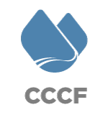
Joseph Teipel Executive Director (719) 204-5071
joseph@chaffeecommunity.org

