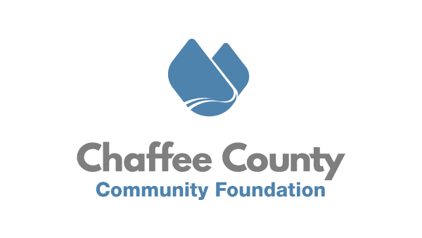

June 2nd, 2021
FOR IMMEDIATE RELEASE
Salida City Council Unanimously Approves Jane’s Place Planned Development
Chaffee County, CO – The Chaffee County Community Foundation (CCCF) applauds the unwavering and unanimous support and leadership of the Salida City Council and City staff for approving the planned development known as Jane’s Place on Tuesday night. Jane’s Place will be an innovative and one-of-a-kind development, combining multiple housing types together with service provision, nonprofit incubator and co-working center, and a social enterprise coffee shop. The project is now approved for development on the currently vacant half-acre lot on the Southwest corner of Highway 291 and 3rd Street.
Jane’s Place will build four buildings including 17 housing units, and 1,375 square feet of nonprofit and community collaboration space on the site. In the model, which has garnered state-wide attention as a unique and innovative approach to housing development, CCCF will own the land itself, and ground lease that land to the Chaffee Housing Authority (CHA) to build and manage the buildings. The housing is designed to serve a wide range of tenants in transition. From individuals and families who find themselves without housing to seasonal employees to new recruits to our workforce needing a place to land, Jane’s Place will fill a gaping hole in Salida’s housing market.
The project is a result of deep community engagement and is being spearheaded by CCCF, CHA, and local architect Robert Grether. “The fact that this project is the perfect combination of right time, right idea(s), right place was on prominent display last night. I’m thankful to be involved and excited to enter the next phase of the development. I ask for the continued support from community members as we work to break ground as quickly as possible.” Says CCCF Executive Director Joseph Teipel.
The success of the project will rest in the continued financial support from the community. To date, more than 50 donors have given over $300,000 to the project. With the City’s approval in hand, raising additional financial support is crucial to breaking ground as quickly as possible. To learn more about the project and to donate, visit https://www.chaffeecommunity.org/janesplace. For questions about supporting the project, please reach out to Joseph Teipel at joseph@chaffeecommunity.org.

###
About Chaffee County Community Foundation (CCCF)
CCCF envisions a resilient Chaffee County where residents, nonprofits, businesses, and governments are thriving, interconnected, and well resourced. CCCF’s mission is to act as a catalyst to inspire positive change through the power of philanthropy to enrich the lives of all people in Chaffee County. To do this, CCCF is working with nonprofits, residents, businesses, and municipal governments to increase philanthropy, provide capacity building and technical support to nonprofits, and invest in catalytic projects in the areas of Community Vitality, Community Health, and Community Capacity. Learn more at www.chaffeecommunity.org.
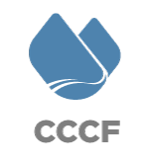
Joseph Teipel Executive Director (719) 204-5071
joseph@chaffeecommunity.org

