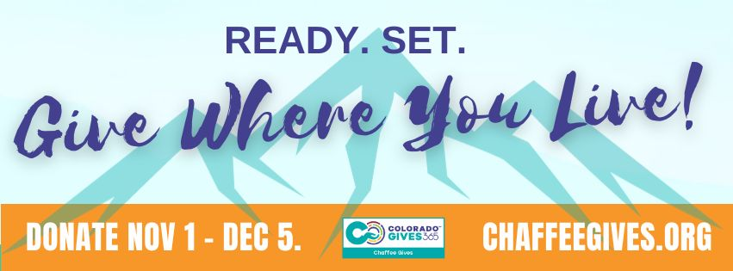

MEDIA ADVISORY

Chaffee County Nonprofits Gearing Up for 2023 Colorado Gives Campaign

WHAT: Chaffee County residents and businesses are invited to give where you live for Colorado Gives Day, the biggest giving movement in the state, on Tues., Dec. 5. This year, Chaffee County Community Foundation (CCCF) is hosting more than 60 local organizations on ChaffeeGIVES.org - the regional champion site for Colorado Gives Day. Giving kicks off Nov. 1 and extends through Colorado Gives Day on Dec. 5, with every donation making the organization eligible for special perks and prizes. As a regional Colorado Gives champion, CCCF manages ChaffeeGIVES.org to inspire potential donors and raise awareness of the local organizations working to build a vibrant community for all. Join local nonprofits as they get materials to kick off their Colorado Gives Day campaigns.

WHEN: Fri., Nov. 3: Colorado Gives Day nonprofit kick off event
Poncha Town Hall - community room, 330 Burnett Ave, Poncha Springs, CO 81242
Live radio remote from 10 a.m. - 12 p.m.

Add’l milestones:
- Wed., Nov. 1: Launch of Colorado Gives Day campaign, early giving opens
- Tues., Nov. 28: Giving Tuesday
- Tues., Dec. 5: Colorado Gives Day

WHO: Betsy Dittenber, Executive Director, CCCF
Leaders and representatives of Chaffee County nonprofits

WHY: Colorado Gives Day is a call to action for all Coloradans to come together with the common goal of leveraging the power of generosity to transform our communities. In 2022, the Colorado Gives movement raised over $53 million, and here in Chaffee County contributions from 2370 unique donors through the ChafeeGIVES.org website totaled $283,174, benefitting 63 local nonprofit organizations.

