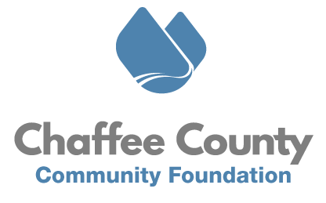
MEDIA ADVISORY

Betsy Dittenber, Executive Director
Chaffee County Community Foundation
719-204-4565
betsy@chaffeecommunity.org

FOR IMMEDIATE RELEASE

CCCF Announces Community Awards at Community Summit

SALIDA, CO (Sept. 18, 2023) – The Chaffee County Community Foundation (CCCF) will announce Community Award winners at the 2023 Community Summit, a day-long program for Chaffee County nonprofits focused on skills building, professional development, leadership growth, and collaboration opportunities. Details below:

What: Community Awards at the CCCF Community Summit
When: Tues., Sept. 19
Time: 4 p.m. Community Awards Reception (Community Summit takes place 8 a.m. - 5 p.m.)
Where: Chaffee County Fairgrounds, 10165 Co Rd 120, Poncha Springs, CO 81201
Registration: Chaffeecommunity.org/summit
Nominees include:
Volunteer of the Year
- Carol Merovka
- Salty Riggs
- Gina Lucrezi
Philanthropist of the Year
- Katy Welter
- Tom Rollings
Organization of the Year
- BETCH
- Full Circle Restorative Justice
- Shining Mountains Montessori School
The Community Summit includes two keynote speakers and workshops in grant writing, nonprofit management, workplace culture, donor pipelines, internships and providing benefits on a budget. The event will include a nonprofit resource fair hosted by regional businesses and organizations that support nonprofit development. The Community Awards reception will conclude the day.
New this year, the Community Summit will feature two tracks. Track one will offer four sessions on fundraising and development for nonprofits. Track two is hosted in partnership with the Chaffee County Economic Development Corporation’s Future of Work Bootcamp and will feature four sessions on Human Resource topics geared to the nonprofit sector.
“At the Chaffee County Community Foundation we recognize and appreciate the hard work of nonprofit leaders in our community.” said Betsy Dittenber, Executive Director of CCCF. “After a day of learning and networking, we’ll celebrate those who are selfless in their service to others, working to address issues that challenge our community and collaborate on solutions.”
Last year’s Community Summit drew more than 40+ nonprofits and over 70 local leaders. The event is open to nonprofit and community agency leaders from the Arkansas River Valley and surrounding regions.

For more information visit Chaffeecommunity.org/summit.
About CCCF
Founded in 2018, Chaffee County Community Foundation is a public, nonprofit organization established to promote and facilitate philanthropy in Chaffee County, created by and for the people in that area. CCCF acts as a catalyst to inspire positive change through the power of philanthropy to enrich the lives of all people within the county. Its goals are to make informed philanthropy accessible to all, build local nonprofit capacity, and enable community conversations. Since 2018, CCCF has actively supported nonprofit organizations for the betterment of Chaffee County and the local communities. To learn more, visit www.chaffeecommunity.org.

# # #

